

DipIT06 – Research And Development Skill in Computing

**AI Based e-commerce system**

**Student Id:** NP03A160064

**Student Name:** Purushottam Tiwari

**B.Sc. (Hons) Computer Science**

**Submitted date:** 5/21/2018

**Submitted to:** Sanjiv Udas

Table of Contents

1. Introduction 1

1.1 Problem Domain 1

1.2 Project as a solution: 2

2. Literature Review: 3

Background 3

Ecommerce and its rising value in market 4

Web-Based Platform 4

Emergence of AI 5

Why Machine Learning? 6

Similar System 6

Analysis: 7

3. Development 8

3.1 Overview 9

3.2 Inception: 9

3.3 Requirement analysis: 9

3.4 Architecture and Design 10

3.5 Development: 10

3.6 Testing and Maintenance: 10

3.7 Why Agile? 10

3.8 Tools and Technique: 12

Hardware requirement 12

4 GB RAM (Read Only Memory) 12

Software requirement 12

Windows 10 12

Technique 12

Django, MySQL database, 12

3.9 Problem Issue 12

4. Project Plan: 14

Work Break Down Structure 14

Gantt Chat 15

5. Conclusion: 17

6. Future Recommendation 17

# Introduction

E-commerce with machine learning is a website of online shopping based on machine learning. Machine learning is a software of artificial intelligence (AI) that provides systems the capability to automatically learn and improve from experience without being explicitly programmed. (Ng, 2018) Machine learning focuses on the development of computer programs that can access information and use it to learn for themselves. As a type of artificial intelligence (AI), machine learning uses algorithms to make computer systems learn besides being explicitly programmed. It is a technique of data analysis that automates analytical model building. Automated analytical model building makes computer systems find hidden insight. Likewise, it makes computer programmers change when exposed to new data. (Magrabi, 2016)

E-commerce can also use machine learning algorithms to recognize customer behavior and raise customer engagement. An e-commerce software can use machine learning to monitor and recognize customer conversations related to a product. It can even use the algorithm to understand the features and functionality expected by the customers. Also, an organization can use machine learning to communicate with customers more efficiently via contact us forms and chat bot. The machine learning algorithm can easily analyze the consumer queries and corporations and transfer the query to the relevant team. Hence, the sales and consumer support teams can easily enhance the consumer experience by resolving problems faster. (Gakuu, 2017)

## 1.1 Problem Domain

The points about the problem are listed below:

* Hard to know about consumer behavior
* Security and Privacy
* Time consuming
* Trust -
* Spam Review
* No communication with seller and buyer
* Lack of customer engagement
* No customer queries and feedback.

## 1.2 Project as a solution:

* Product recommendation:

The integrated AI into the ecommerce system helps users or customers recommend their desired product based on their browsing activity. Users do not find the product as per their needs on the website. This has a major issue with ongoing ecommerce applications. So, to solve it, our website analyses the demand through integrated AI and recommends it to them.

* Query expansion:

Machine learning has many aspects as chatbot is one of them. The integration of AI in ecommerce chatbot helps to answer the query that user/customer asks. This helps users to be more engaged with the system.

* Fraud detection/ Fake review:

Sometimes user do not buy anything from the ecommerce system but they review about the services. This is a major issue in e commerce applications. So, to solve this issue the integration in AI helps to find fraud detection and fake review about the ecommerce application. (Oommen, 2017).

# Literature Review:

## Background

Generally, interpersonal trust is focused if we discuss normal commerce such as a customer believes in a salesperson. customer trust may want to have more than one referents like a product, salesperson, and organization and accordingly defined trust as a global belief on the part of the buyer that the salesperson, product, and organization will fulfill their obligations as understood by the buyer. E-commerce is a website so it is focused on every digital which is used for browsing like: android, IOS, and PC which has a browser to browse our website. The AI based e-commerce platform that is going to be developed is a web-based e-commerce service. As all of the internet users, all over the world are already familiar with the web, this system will also be focused on the web so that every user around the world could access it easily.

## Ecommerce and its rising value in market

Around the world, e-commerce is changing the way people shop. In the primary purchaser markets of Europe, the USA and China, e-commerce is quickly becoming the preferred buying technique for many people. Over the course of the last decade, E-commerce firms have taken the consumer market by storm. (Cole, 2016)

Amazon, the largest e-commerce firm in the world is currently valued at more that $750 billion, making it the second most valuable company all over the world. (Poletti, 2018). Similarly, the second biggest E-commerce firm i.e. Alibaba is also valued at more than $500 billion. (MarketWatch, 2018). Other than Amazon and Alibaba, there are other e-commerce firms as well like Flipkart, eBay, Rakuten, Snapdeal which are valued at billions of dollars, making them one of the most valuable companies in their respective countries.

None of those companies had such valuation until last decade. (Cole, 2016). The market is rapidly shifting from retail to e-commerce which is making the valuation of e-commerce more promising for times to come. (FinancialBuzz, 2017)

## Web-Based Platform

The Web has been one of the most effective, easy and reliable ways of browsing through the Internet. The growth of the web has become explosive in the past 20 years’ time. (Shuler, 2002)The working mechanism of a web-platform can be clarified from the below diagram:

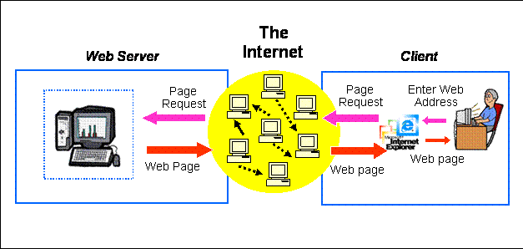

*Figure 1 Web Based Architecture*

In the above figure, there is a different type of client who is using a different PC and is browsing through the browser. The user is using the web-based system through the browser. When he/she requests certain things on the system, then at first it hits the web server with the help of the internet and again with the help of the internet web server hits the request of the client to the database server then after the database server looks the request of the client into the database. After getting the things requested by the client in the database, the database server sends it to the web server through the internet and the web server sends it to the system used by the user through the internet. This way a user gets his desired result set through the web. (Newman, et al., 2018).

## Emergence of AI

Machine learning is defined as the science of getting computers to act without being explicitly programmed. Based on pattern recognition and computational learning theories in artificial intelligence, machine learning uses the study and building of algorithms to analyze from and make predictions on data. (Oommen, 2017). Machine learning is an application, which is also a sub-set of Artificial Intelligence where algorithms are used to autonomously learn from data and information. In machine learning, explicitly programmed algorithms don't take place but can change and improve their algorithms by themselves. Nowadays, machine learning has many features like: self-driving cars, chat bot, auto-recommendation, virtual assistance, and so on. (Marr, 2016).

## Why Machine Learning?

There are many reasons why to use machine learning in applications and websites. There are some points that describe why machine learning. These are listed below:

* Chatbot/ AI Assistance:

Responding to client inquiries, responding to voice instructions for simple tasks and providing product suggestions through interactions using natural language.

* Smart Logistic:

Machine learning is being applied in many ways to help data to automated warehouse operation where algorithms are mostly used.

* Recommendation Engine:

Analyzing the customer/client behavior and recommend the product that customer has been familiar with or most of the time they use. Recommending the product or likely product which the customer/client is using most of the time. (Sennaar, 2018)

## Similar System

1. Amazon

Amazon is considered as the world’s top e-commerce platform hence earns a spot in the top 10 e-commerce websites in the world. People love to shop on this website because of its user interface, easy, simple, payment and have great discounts and offers.

1. Walmart

Walmart malls are a popular shopping destination in America. Walmart offers home appliances, toys, electronics, fashion accessories, sport, etc.

1. eBay

On eBay, customers cannot buy different products but also get to sell products to the buyer. Customers can make purchases with the help of the eBay store web application and add content along with images and description.

1. Alibaba
2. FlipKart

These all are E-commerce sites which use machine learning like: message chat bot, product recommendation, and soon.

Some similar E-commerce websites with AI based E-commerce websites in Nepal are as follows:

1. Nepbay
2. MeroShopping
3. Harilo
4. Foodmandu
5. Estorenepal

## Analysis:

Despite all these E-commerce sites with similar functionality still the management in E-commerce websites has not been so effective in Nepal. Even though there is a message chat bot on every website, there are no proper product recommendations and fake reviews. Because it is not easy to implement the machine learning on the website and due to cost also.

Beside all these problems that occur in E-commerce it is not so easy for the developer to develop a machine learning website that uses product recommendation, fake review, etc. So, to avoid all these problems this project helps to develop full stack web based E-commerce site with machine learning to find fake reviews, product recommendation and more.

# Development

The methodology used for making the ecommerce website with machine learning is agile method.

## Overview

Agile model is a combination of iterative and incremental method models with a focus on method adaptability and consumer satisfaction by rapid delivery of working software products.

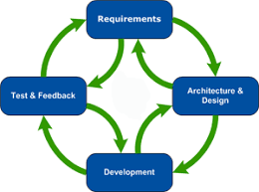

*Figure 2: Agile Model Life Cycle*

## Inception:

When the project is identified, work with stakeholders to determine the requirement. User flow diagram, class diagram, UML diagram, etc. to demonstrate how the feature of the system should function and how it will fit in the existing system. ( Lucidchart Content Team, 2017).

## Requirement analysis:

The agile methodology is used whereas requirement analysis is the first step where all the requirements needed for the project are planned. In this step, what kind of hardware and software are required are planned. Testers test the requirement and plans that are fulfilled or not. In this step, individual and interaction between the tools and technique. (Arzadon, 2016).

## Architecture and Design

This is the second step of the agile method. In this step, system architecture and design take place. Here, the customer got the actual design of the system and actual architecture of the system. Project success, consumer satisfaction and system quality are also developed when designing the system. (Rico, 2012).

## Development:

When the requirement of the project is finished, the development phase takes place when designing the prototype of the system is finished. Development phase occurs and the system is developed according to the stakeholder feedback. UI is developed in the designing and architecture phase. ( Lucidchart Content Team, 2017).

## Testing and Maintenance:

Testers test the system after all phases are finished because of the combination of iterative and incremental methodology. To maintain the system, testing is necessary. After developing the system, maintenance is necessary to bug or viruses free and also make the system update/upgrade to the new system. (Vashishtha, 2008).

## Why Agile?

Some points describing the usage of agile methodology, they are:

* Stakeholder Engagement:

Agile presents more than one opportunity for stakeholder and team engagement – before, during, and after each Sprint. By involving the customer in every step of the project, there is a high degree of collaboration between the customer and project team, providing extra opportunities for the group to truly understand the client’s vision.

* Transparency:

An Agile method provides a special opportunity for customers to be involved throughout the project, from prioritizing features to iteration planning and review sessions to frequent software build containing new features.

* Predictable cost and schedule:

Because every Sprint is a constant duration, the price is predictable and limited to the amount of work that can be carried out by the team in the fixed-schedule time box. Combined with the estimates furnished to the consumer prior to every Sprint, the patron can more comfortably apprehend the approximate value of each feature, which improves choice making about the precedence of elements and the want for additional iterations. (Technologies, 2015).

## Tools and Technique:

| Hardware requirement | 4 GB RAM (Read Only Memory) 120 GB ROM (Read Only Memory)  LAN (Local Area Network)  Router |
| --- | --- |
| Software requirement | Windows 10 IDE: Bracket, Notepad++, sublime etc.  Microsoft Office: Microsoft word, Microsoft Excel, Microsoft outlook, etc.  Programming language: JavaScript, Python, PHP.  Markup language: HTML5, CSS3 |
| Technique | Django, MySQL database, |

## 

There are various algorithms for machine learning. This system will also be made with the implementation of some major algorithms. The appropriate one will be added in the project later.

## Problem Issue

Different issues may occur during the project. Some of them may be known or some of them may be unknown. They are:

1. Server down
2. Programming language does not support the system
3. System crash
4. System lost (Laptop lost)
5. Shortage of resources

To overcome the problem there are some solutions, they are:

1. Strong server maintenance.
2. Systems must be up to date to support the programming language.
3. Back up for the project (drive, pen drive, external hard drive, etc.)

# Project Plan:

## Work Breakdown Structure

| Level 1 | Level 2 | Level 3 |
| --- | --- | --- |
| 1 AI based E-commerce website | 1.1 Initiation | 1.1.1 Define Project Phase  1.1.2 Project Scope  1.1.3 Project Charter  1.1.4 Feasibility Study  1.1.5 Analyze Stakeholder |
| 1.2 Planning | 1.2.1 Project Organization chart  1.2.2 Work Break Structure  1.2.3 Project Management Plan  1.2.4 Develop Project Plan  1.2.5 Milestone: Project Plan Approval |
| 1.3 Execution | 1.3.1 Build Deliverable  1.3.2 Change Request  1.3.3 Design System  1.3.4 Project Risk  1.3.5 Install Development System  1.3.6 Testing Phase  1.3.7 Production Transition  1.3.8 Status Report |
| 1.4 Control | 1.4.1 Update Project Management Plan  1.4.2 Project Management  1.4.3 Project Status Meetings  1.4.4 Risk Management |
| 1.5 Closeout | 1.5.1 User Acceptance  1.5.2 Documentation  1.5.3 Project Closure Report |

## Gantt Chart

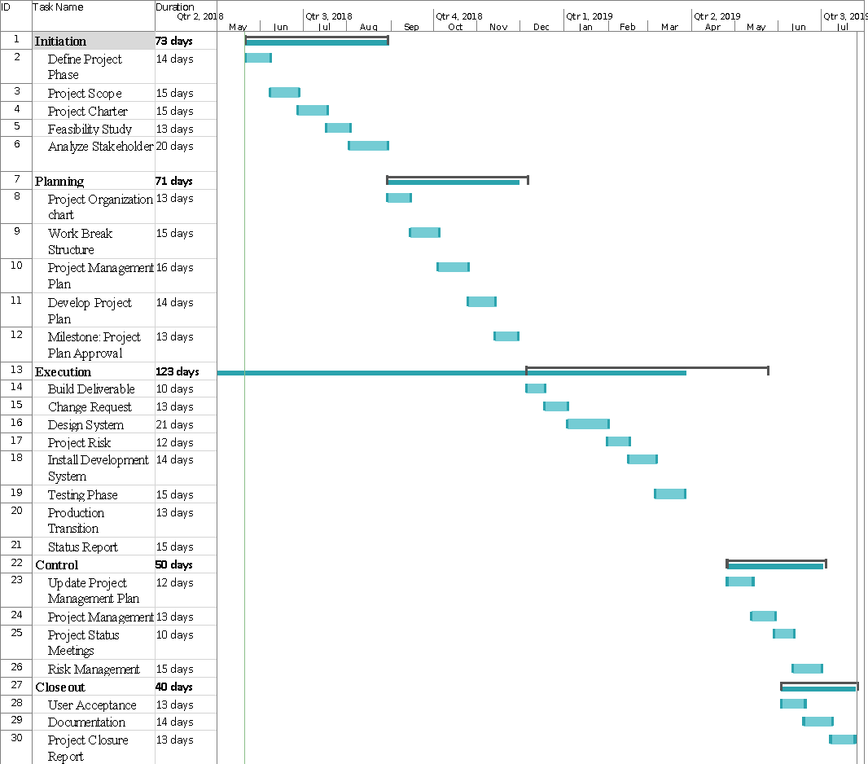

# Conclusion:

At last, machine learning is a vast topic which helps to predict the outcome recommending the out to the customer and also helps in small query that are asked by the client/customer. It is also logistic which help to manipulate the data from warehouse. Machine learning are widely used all over the world to solve many realistic problems by recommending, storing data, extracting and retrieving data. In this topic, we have discussed about the machine learning and used of machine learning in E-commerce website, methodology used in the project, problem and the solution as the project.

# Future Recommendation

In future the AI based ecommerce could be developed more diverse with many other features. With additional features like AI integrated review and spam checking feature, the system could be more helpful for users and owners. Similarly, the blockchain can also be implemented in this system to avoid fraud activity and to ensure payment and delivery. Moreover, the integrated AI system could also act as a digital assistant to the users and members of our system. With these all exciting features, this ecommerce system can be the top-leading system in a nation.

Lucidchart Content Team, 2017. *Lucid Chart.* [Online]   
Available at: https://www.lucidchart.com/blog/agile-software-development-life-cycle

Arzadon, M. A., 2016. *Linkedin.* [Online]   
Available at: https://www.linkedin.com/pulse/requirements-analysis-agile-world-mary-antoinette-arzadon

Cole, L., 2016. *The Rise and Rise of e-Commerce: Statistics, Trends and How Your Business Can Capitalize.* [Online]   
Available at: https://www.business2community.com/ecommerce/rise-rise-e-commerce-statistics-trends-business-can-capitalize-01456979  
[Accessed 18 May 2018].

FinancialBuzz, 2017. *E-commerce Market is on the Rise in the U.S and Around the World.* [Online]   
Available at: https://www.prnewswire.com/news-releases/e-commerce-market-is-on-the-rise-in-the-us-and-around-the-world-657968043.html  
[Accessed 18 May 2018].

Gakuu, D., 2017. *linkedin.* [Online]   
Available at: https://www.linkedin.com/pulse/top-5-machine-learning-applications-e-commerce-derrick-gakuu

Magrabi, A., 2016. *Commercetools.* [Online]   
Available at: https://techblog.commercetools.com/top-5-machine-learning-applications-for-e-commerce-268eb1c89607

MarketWatch, 2018. *Alibaba Group Holding Ltd..* [Online]   
Available at: https://www.marketwatch.com/investing/stock/baba  
[Accessed 18 May 2018].

Marr, B., 2016. *Forbes.* [Online]   
Available at: https://www.forbes.com/sites/bernardmarr/2016/02/19/a-short-history-of-machine-learning-every-manager-should-read/#20eef6e015e7

Newman, C., Agioutantis, Z. & Schaefer, N., 2018. *A New Generation of Web-Based Applications for Mine Design,* s.l.: Department of Mining Engineering University of Kentucky Lexington, KY.

Ng, A., 2018. *Coursera.* [Online]   
Available at: https://www.coursera.org/learn/machine-learning

Oommen, N., 2017. *ZYXWARE.* [Online]   
Available at: https://www.zyxware.com/articles/5731/how-can-machine-learning-help-ecommerce

Poletti, T., 2018. *Amazon heads toward $700 billion valuation thanks to Alexa, AWS and tax gains.* [Online]   
Available at: https://www.marketwatch.com/story/amazon-heads-toward-700-billion-valuation-thanks-to-alexa-aws-and-tax-gains-2018-02-01  
[Accessed 13 May 2018].

Rico, D., 2012. *Project management.com.* [Online]   
Available at: https://www.projectmanagement.com/articles/274313/Architecture-and-Design-Practices-for-Agile-Project-Management

Sennaar, K., 2018. *techemergence.* [Online]   
Available at: https://www.techemergence.com/artificial-intelligence-in-ecommerce-amazon-alibaba-jd-com/

Shuler, R., 2002. *How Does the Internet Work?.* [Online]   
Available at: https://web.stanford.edu/class/msande91si/www-spr04/readings/week1/InternetWhitepaper.htm  
[Accessed 13 May 2018].

Technologies, S., 2015. *Segue Technologies.* [Online]   
Available at: https://www.seguetech.com/8-benefits-of-agile-software-development/

Vashishtha, S., 2008. *xebia.* [Online]   
Available at: http://blog.xebia.com/preparing-for-agile-maintenance-knowledge-management/